DATABASE DESIGN DOCUMENT
Name of Project: Electronic Device Helpdesk Support System (Bug Reporting & Telecom Support System)
I. ER/Class Diagram
1.1. User Role Hierarchy & Access Control Class Diagram (6 Department Roles):
Illustrates the inheritance hierarchy of system users across all 6 authorized department roles (Admin, Dispatch & Order Management Dept, Call Center Staff, Technical Support Team, Back End Mail Team, and Accounts Dept) synchronized with Form 02A.
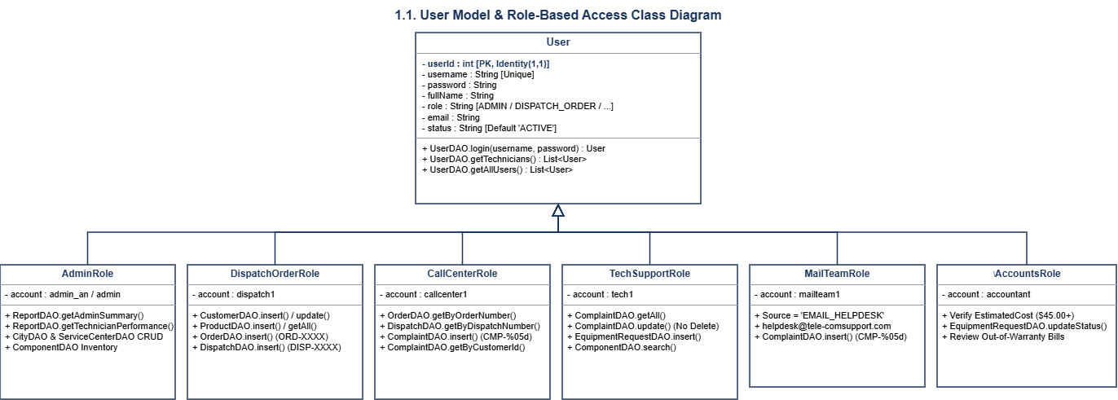
1.2. Entity-Relationship (ER) & Domain Class Diagram (8 Core Database Tables):
Illustrates the 8 relational database entities (Users, Customers, Products, Orders, Dispatches, Warranties, Complaints, and Complaint_Updates), their primary/foreign key constraints, cardinalities, and core business methods.
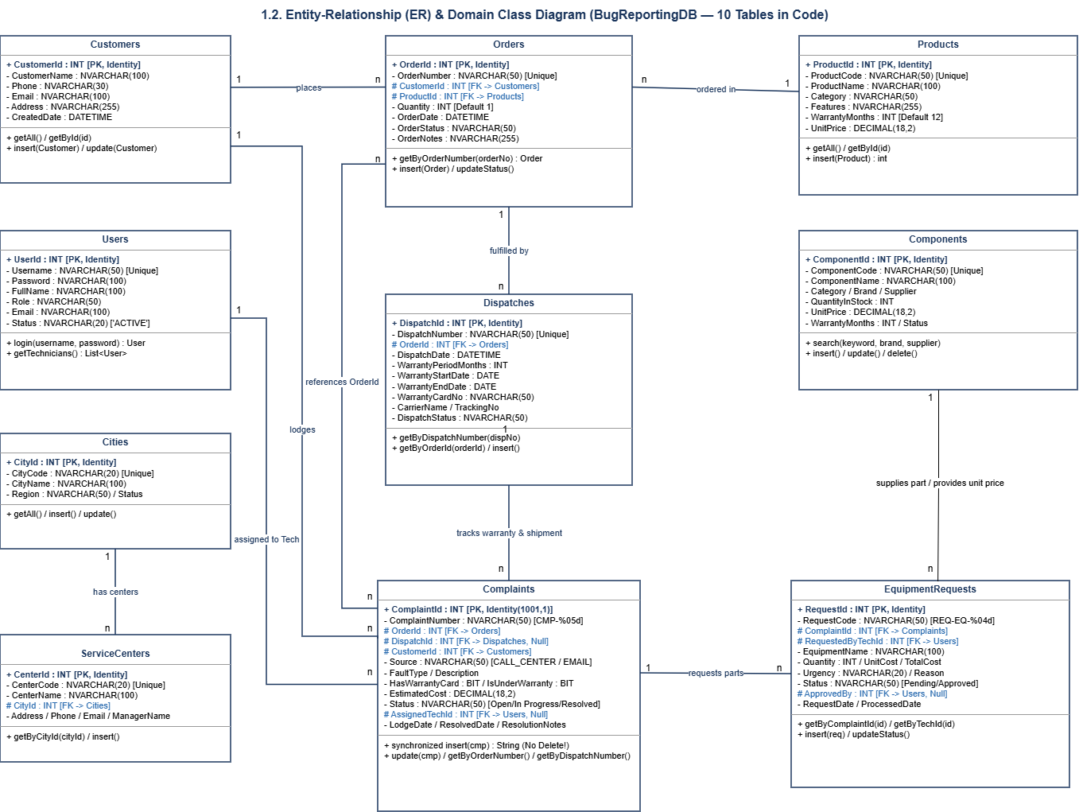
II. Table Description
1. Users
Field Name | Data Type | Constraint (Primary Key, Foreign Key, Identity, Not Null,...) | Description
UserId | INT | PRIMARY KEY, IDENTITY(1,1) | Unique identifier for system staff.
Username | NVARCHAR(50) | UNIQUE, NOT NULL | Unique login username (e.g., admin_an, dispatch1, callcenter1, tech1, mailteam1, accountant).
Password | NVARCHAR(100) | NOT NULL | Account password authenticated by UserDAO.login().
FullName | NVARCHAR(100) | NOT NULL | Full name of the staff member (used for technician assignment and turnaround reports).
Role | NVARCHAR(50) | NOT NULL | Department role code ('ADMIN', 'DISPATCH_ORDER', 'ACCOUNTS', 'CALL_CENTER', 'TECH_SUPPORT', 'MAIL_TEAM').
Email | NVARCHAR(100) | NULL | Staff or department email address (e.g., helpdesk@tele-comsupport.com).
Status | NVARCHAR(20) | DEFAULT 'ACTIVE' | Account status ('ACTIVE' / 'INACTIVE').

2. Cities
Field Name | Data Type | Constraint (Primary Key, Foreign Key, Identity, Not Null,...) | Description
CityId | INT | PRIMARY KEY, IDENTITY(1,1) | Unique identifier for the city/province.
CityCode | NVARCHAR(20) | UNIQUE, NOT NULL | Short city code (e.g., 'HN', 'HCM', 'DN', 'HP', 'CT').
CityName | NVARCHAR(100) | NOT NULL | Full name of the city (e.g., Ha Noi, Ho Chi Minh, Da Nang, Can Tho).
Region | NVARCHAR(50) | NULL | Geographic region (Mien Bac, Mien Trung, Mien Nam).
Status | NVARCHAR(20) | DEFAULT 'ACTIVE' | Operational status of the city.

3. ServiceCenters
Field Name | Data Type | Constraint (Primary Key, Foreign Key, Identity, Not Null,...) | Description
CenterId | INT | PRIMARY KEY, IDENTITY(1,1) | Unique identifier for the regional service center.
CenterCode | NVARCHAR(20) | UNIQUE, NOT NULL | Unique center code (e.g., 'CTR-HN01', 'CTR-HCM01', 'CTR-DN01').
CenterName | NVARCHAR(100) | NOT NULL | Name of the warranty/service center.
CityId | INT | FOREIGN KEY REFERENCES Cities(CityId), NOT NULL | City where the service center is located.
Address | NVARCHAR(255) | NOT NULL | Street address of the service center.
Phone | NVARCHAR(30) | NOT NULL | Contact phone number of the service center.
Email | NVARCHAR(100) | NULL | Contact email of the service center.
ManagerName | NVARCHAR(100) | NULL | Full name of the center manager.
Status | NVARCHAR(20) | DEFAULT 'ACTIVE' | Operational status ('ACTIVE' / 'INACTIVE').

4. Customers
Field Name | Data Type | Constraint (Primary Key, Foreign Key, Identity, Not Null,...) | Description
CustomerId | INT | PRIMARY KEY, IDENTITY(1,1) | Unique identifier for the customer.
CustomerName | NVARCHAR(100) | NOT NULL | Customer or corporate client name (e.g., BSNL Corporate Office).
Phone | NVARCHAR(30) | NOT NULL | Primary contact phone number.
Email | NVARCHAR(100) | NULL | Customer contact email address.
Address | NVARCHAR(255) | NULL | Billing and shipping address of the customer.
CreatedDate | DATETIME | DEFAULT GETDATE() | Timestamp when the customer profile was registered.

5. Products
Field Name | Data Type | Constraint (Primary Key, Foreign Key, Identity, Not Null,...) | Description
ProductId | INT | PRIMARY KEY, IDENTITY(1,1) | Unique identifier for the telecom product.
ProductCode | NVARCHAR(50) | UNIQUE, NOT NULL | Unique product SKU code (e.g., 'TEL-MOB-01', 'TEL-LL-02', 'TEL-WL-03').
ProductName | NVARCHAR(100) | NOT NULL | Name of the telecom product (e.g., Pro Telecom Mobile 5G, Office Landline Deluxe).
Category | NVARCHAR(50) | NOT NULL | Product category ('Mobile', 'Landline', 'Wireless Phone', 'VoIP Terminal').
Features | NVARCHAR(255) | NULL | Built-in features (Speaker phone, Caller ID, Answering Machine, SMS, Voice Recording).
WarrantyMonths | INT | DEFAULT 12 | Default manufacturer warranty duration in months (12, 24, 36).
UnitPrice | DECIMAL(18,2) | DEFAULT 0.00 | Standard unit price of the product.

6. Orders
Field Name | Data Type | Constraint (Primary Key, Foreign Key, Identity, Not Null,...) | Description
OrderId | INT | PRIMARY KEY, IDENTITY(1,1) | Internal unique identifier for the order.
OrderNumber | NVARCHAR(50) | UNIQUE, NOT NULL | Unique business Order Number (e.g., 'ORD-1001', 'ORD-1002') used for tracking.
CustomerId | INT | FOREIGN KEY REFERENCES Customers(CustomerId), NOT NULL | Customer who placed the order.
ProductId | INT | FOREIGN KEY REFERENCES Products(ProductId), NOT NULL | Ordered telecom product.
Quantity | INT | DEFAULT 1 | Quantity of devices ordered.
OrderDate | DATETIME | DEFAULT GETDATE() | Date and time the order was placed.
OrderStatus | NVARCHAR(50) | DEFAULT 'Pending' | Order lifecycle status ('Pending', 'Dispatched', 'Completed', 'Cancelled').
OrderNotes | NVARCHAR(255) | NULL | Additional notes or delivery instructions.

7. Dispatches
Field Name | Data Type | Constraint (Primary Key, Foreign Key, Identity, Not Null,...) | Description
DispatchId | INT | PRIMARY KEY, IDENTITY(1,1) | Internal unique identifier for the dispatch record.
DispatchNumber | NVARCHAR(50) | UNIQUE, NOT NULL | Unique Dispatch Number (e.g., 'DISP-5001') specific to the order.
OrderId | INT | FOREIGN KEY REFERENCES Orders(OrderId), NOT NULL | Linked Order ID being shipped.
DispatchDate | DATETIME | DEFAULT GETDATE() | Date and time the shipment was dispatched.
WarrantyPeriodMonths | INT | NOT NULL | Warranty duration in months assigned upon dispatch.
WarrantyStartDate | DATE | NOT NULL | Start date of product warranty coverage.
WarrantyEndDate | DATE | NOT NULL | Expiration date of product warranty (checked during complaint lodging).
WarrantyCardNo | NVARCHAR(50) | NOT NULL | Unique Warranty Card Number issued with the dispatch (e.g., 'WARR-9901').
CarrierName | NVARCHAR(100) | NULL | Shipping carrier name (e.g., BlueDart, DHL Express).
TrackingNo | NVARCHAR(100) | NULL | Courier shipment tracking code.
DispatchStatus | NVARCHAR(50) | DEFAULT 'Delivered' | Current shipment status ('Dispatched', 'In Transit', 'Delivered').

8. Complaints
Field Name | Data Type | Constraint (Primary Key, Foreign Key, Identity, Not Null,...) | Description
ComplaintId | INT | PRIMARY KEY, IDENTITY(1001,1) | Internal auto-incrementing ID starting at 1001 (strictly non-deletable).
ComplaintNumber | NVARCHAR(50) | NOT NULL | Auto-generated sequential Complaint Number (e.g., 'CMP-01001', 'CMP-01003').
OrderId | INT | FOREIGN KEY REFERENCES Orders(OrderId), NOT NULL | Linked Order ID for tracking.
DispatchId | INT | FOREIGN KEY REFERENCES Dispatches(DispatchId), NULL | Linked Dispatch ID for warranty and shipment lookup.
CustomerId | INT | FOREIGN KEY REFERENCES Customers(CustomerId), NOT NULL | Customer who lodged the complaint (enables customer complaint history lookup).
Source | NVARCHAR(50) | DEFAULT 'CALL_CENTER' | Intake channel ('CALL_CENTER' or 'EMAIL_HELPDESK' via helpdesk@tele-comsupport.com).
FaultType | NVARCHAR(100) | NOT NULL | Fault classification (e.g., Speaker Phone Static, Answering Machine Failure).
Description | NVARCHAR(MAX) | NOT NULL | Detailed fault description reported by the customer.
HasWarrantyCard | BIT | DEFAULT 0 | Indicates whether the customer presented a valid warranty card (1 = Yes, 0 = No).
IsUnderWarranty | BIT | DEFAULT 0 | Indicates whether the device is within active warranty coverage (1 = Yes, 0 = No).
EstimatedCost | DECIMAL(18,2) | DEFAULT 0.00 | Calculated service charge ($0.00 if under warranty with card; $45.00+ if chargeable).
Status | NVARCHAR(50) | DEFAULT 'Open' | Complaint status ('Open', 'In Progress', 'Resolved', 'Closed').
AssignedTechId | INT | FOREIGN KEY REFERENCES Users(UserId), NULL | ID of the Technical Support engineer assigned to resolve the ticket.
LodgeDate | DATETIME | DEFAULT GETDATE() | Timestamp when the complaint was lodged.
ResolvedDate | DATETIME | NULL | Timestamp when status became 'Resolved'/'Closed' (used by ReportDAO to compute turnaround hours).
ResolutionNotes | NVARCHAR(MAX) | NULL | Technical repair notes updated by Technical Support.

9. Components
Field Name | Data Type | Constraint (Primary Key, Foreign Key, Identity, Not Null,...) | Description
ComponentId | INT | PRIMARY KEY, IDENTITY(1,1) | Unique identifier for spare part / hardware component.
ComponentCode | NVARCHAR(50) | UNIQUE, NOT NULL | Component SKU code (e.g., 'COMP-TOSH-001', 'COMP-SONY-001').
ComponentName | NVARCHAR(100) | NOT NULL | Name of the replacement component.
Category | NVARCHAR(50) | NOT NULL | Component category ('Chipset', 'IC', 'Display', 'Audio', 'Power', 'Cable').
Brand | NVARCHAR(50) | NOT NULL | Manufacturer brand (Toshiba, Sony, Panasonic, Texas Instruments, Foxconn).
Supplier | NVARCHAR(100) | NOT NULL | Authorized component supplier (e.g., Hong Phat Store, Minh Duc Electronics).
QuantityInStock | INT | DEFAULT 0 | Available inventory quantity in stock.
UnitPrice | DECIMAL(18,2) | DEFAULT 0.00 | Unit replacement price of the component.
WarrantyMonths | INT | DEFAULT 12 | Component warranty duration in months.
Status | NVARCHAR(20) | DEFAULT 'ACTIVE' | Inventory status ('ACTIVE' / 'OUT_OF_STOCK').
Description | NVARCHAR(255) | NULL | Technical specification of the spare part.

10. EquipmentRequests
Field Name | Data Type | Constraint (Primary Key, Foreign Key, Identity, Not Null,...) | Description
RequestId | INT | PRIMARY KEY, IDENTITY(1,1) | Unique identifier for the spare part / equipment request.
RequestCode | NVARCHAR(50) | UNIQUE, NOT NULL | Auto-generated sequential code (e.g., 'REQ-EQ-1001').
ComplaintId | INT | FOREIGN KEY REFERENCES Complaints(ComplaintId), NOT NULL | Complaint ticket requiring the replacement part.
RequestedByTechId | INT | FOREIGN KEY REFERENCES Users(UserId), NOT NULL | Technician who requested the component.
EquipmentName | NVARCHAR(100) | NOT NULL | Name of the requested spare part / equipment.
Quantity | INT | DEFAULT 1 | Requested quantity.
UnitCost | DECIMAL(18,2) | DEFAULT 0.00 | Unit cost of the part.
TotalCost | DECIMAL(18,2) | DEFAULT 0.00 | Total calculated part cost (Quantity * UnitCost).
Urgency | NVARCHAR(20) | DEFAULT 'Normal' | Priority level ('Normal', 'High', 'Urgent').
Reason | NVARCHAR(255) | NULL | Justification for part replacement.
Status | NVARCHAR(50) | DEFAULT 'Pending' | Approval status ('Pending', 'Approved', 'Dispatched', 'Rejected').
ApprovedBy | INT | FOREIGN KEY REFERENCES Users(UserId), NULL | User ID of the Admin/Accounts staff who approved the request.
RequestDate | DATETIME | DEFAULT GETDATE() | Timestamp when the part request was created.
ProcessedDate | DATETIME | NULL | Timestamp when the request was approved/processed.

